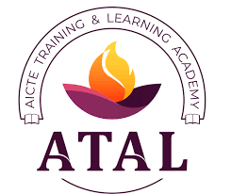 | 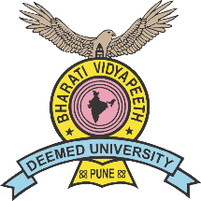

Bharati Vidyapeeth’s College of Engineering for Women
Faculty Development Program (FDP)
On
“Research Opportunities in Sustainable Development Using GIS Technologies”
Sponsored by AICTE Training and Learning (ATAL) Academy
11th to 16th NOVEMBER 2024

Industry Visit Report
Location: Maharashtra Remote Sensing Application Centre, Pune. (MRSAC)
Resource Person: Dr. Sanjay Patil
Sr. Scientist, MASAC, Pune
Date: 14/11/2024
Dr. Sanjay Patil delivered an engaging and insightful explanation of GIS and remote sensing, showcasing his deep understanding and passion for the subject. His session was highly informative and left participants with a clear appreciation of the practical applications and potential of these technologies.
The Maharashtra Remote Sensing Application Centre (MRSAC) plays a pivotal role in advancing the use of GIS and remote sensing across the state. Collaborating closely with the Planning Department of the Government of Maharashtra, MRSAC has expanded its presence with centres in Mumbai (established in 2013) and Pune (established in 2014). MRSAC also emphasizes training and capacity-building, providing soft skill workshops and technical education to a diverse audience. This includes government officials, administrators, non-governmental organizations (NGOs), and students from universities across Maharashtra. By equipping stakeholders with the necessary skills and knowledge, MRSAC ensures the effective utilization of advanced technologies in addressing real-world challenges.
A key focus of MRSAC is empowering the state with scientific inputs derived from cutting-edge tools and technologies. Leveraging an extensive and diverse digital database, the organization offers solutions tailored to a wide range of thematic areas.

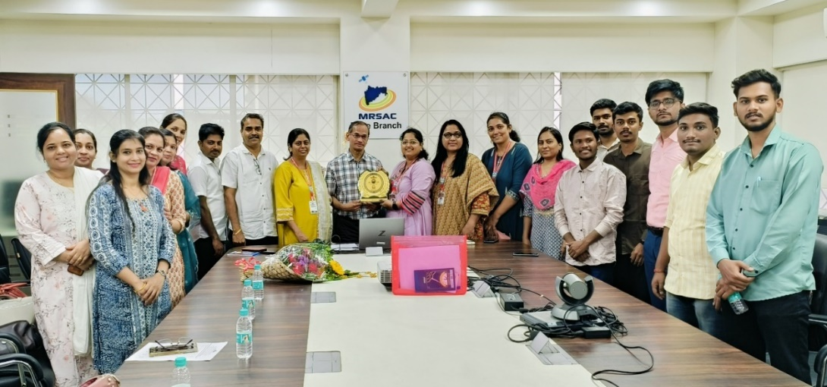
Photo: Industry Visit at MRSAC, Pune.

Today, MRSAC stands as a leader in natural resource monitoring and management, recognized for its expertise in GIS and related technologies.
Prepared By
Prof Sagar G Janorkar
Vishwakarma Institute of Technology,Pune-37.

